objective
City Store want to create an annual sales report for 2022. So that,
city Store can understand their customers and grow more sales in 2023.
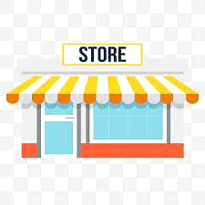

Sample Question :
Compare the sales and orders using single charts.
Which months got the highest sales and orders.
Who purchased more-men or women in 2022?
What are different order status in 2022 ?
List Top 5 states contributing to the sales ?
Relation between age and gender based on number sales.
Which channel is contributing to maximum sales ?
Highest selling category ? etc.

